

|  |  |  |  |  |  |  |  |  |  |  |  |  |  |  |  |  |
| --- | --- | --- | --- | --- | --- | --- | --- | --- | --- | --- | --- | --- | --- | --- | --- | --- |
|  | | | | | | | | | | | | | | | | |
|  | | ACADEMIC FIELD TRIP REPORT | | | | | | | | | | | | |  | |
|  |  | | | | | | | | | | | | | | |  |
|  | | | | |  | | | | | | |  | | | | |
|  | | | | | Emmanuel Kenneth KibetP101/2259G/22 | | | | | | |  | | | | |
|  | | | | | *Date*27/01/2025-01/02/2025*Course title*Computer Science | | | | | | |  | | | | |
|  | | | |  | | | | | | | | |  | | | |
|  | | | INTRODUCTION | | | | | | | | | | |  | | | |
|  | | |  | | | | |  |  | | | | |  | | | |
|  | | |  | | | |  | | |  | | | |  | | | |
|  | | |  | | |  | This report provides a detailed account of the five-day academic field trip undertaken by students from Karatina University. The trip spanned from Nairobi to Mombasa, with visits to key technological and educational institutions, including Multimedia University, Konza Technopolis, and the Mombasa Cable Landing Station. The purpose of the trip was to expose students to the evolution and current state of information and communication technologies (ICT) in Kenya, as well as to provide insights into the infrastructure supporting Kenya's digital economy. | | |  |  | | |  | | | |
|  | | | | |
|  | | |  | | |  | | |  | | | |
|  | | |  | | |



## Day 1: Visit to Multimedia University, Nairobi

The trip commenced with a visit to Multimedia University in Nairobi. The first stop was the ICT Museum, established in October 2010 under the Research, Production, and Extensions department. It is currently headed by Mr. Samuel Odoyo. The museum showcases the history of ICT in East Africa, with galleries and artifacts ranging from postal and philatelic history to the evolution of telephony, radio, computers, and mobile phones.

Activities:

***ICT Museum Tour:***

We were guided through the history of computers, telecommunications, and data technologies in East Africa dating back to 1901, including an evolution of keyboards (from wired to wireless), electronic passwords, telex machines, copper wires, radio, optical fiber cables, fax mail, and microphones.

The museum exhibition hall comprises galleries and artifacts ranging from:

**East Africa Postal & Philatelic History**: Study of stamps and postal artifacts.

**Telephony, Radio & Radio Transmissions History**: Evolution of communication technologies.

**Computer History**: Artifacts showing the evolution of computing, including a 300-year-old Abacus, the slide rule, the first calculator (circa 1900), vacuum tubes (1904), transistors (1950), and the advent of integrated circuits (ICs).

**Film Media History & Mobile Phones History**: Displaying how technology and media evolved.

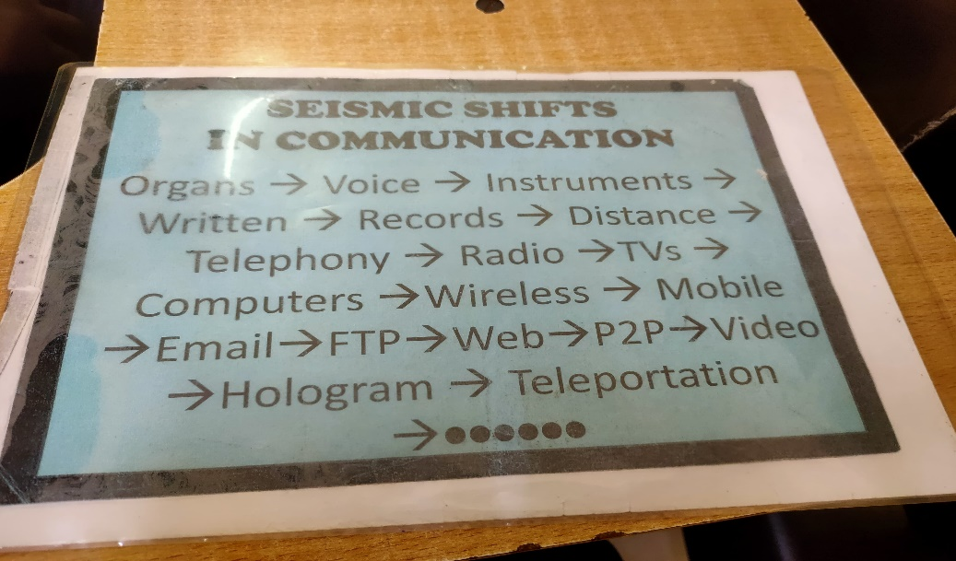

***Radio Broadcasting Tour***

We visited MMU Radio, a community radio station that serves Rongai and its environs (Frequency: 99.9 FM, covering a 25 km radius).

The tour included

* A look at the live broadcasting process, showcasing equipment such as the Broadcasting Console, Condenser Microphone, and Profanity Delayer (a 7-second delay system to filter content).
* We also noted features such as echo control (via holes in the walls) and the types of events produced in the recording room (adverts, features, and news reports).

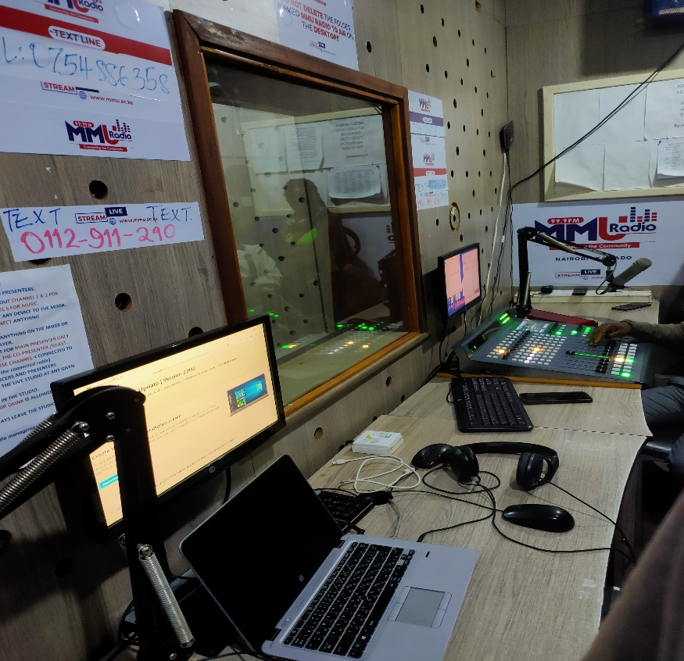

After the visit, we were accommodated in Nairobi for the night.

## Day 2: Konza City – Konza Technopolis Visit

On the second day, we traveled to Konza Technopolis, a flagship project under Kenya's Vision 2030. Konza is envisioned as a world-class technology hub, often referred to as "Silicon Savannah," located 64 km south of Nairobi on the way to Mombasa

Activities:

**Network Operations and Infrastructure Tour:**

We visited the Network Operation Centre (NOC) and observed the monitoring of operations using both outsourced and custom-made monitoring platforms.

The tour included insights into:

**Monitoring Platforms:** Outsourced and custom-made systems for resource allocation.

**Cloud Computing Models:**

* **Software as a Service (SaaS):** Applications hosted on cloud servers and accessed via the internet, eliminating the need for local installation.
* **Platform as a Service (PaaS):** Platforms that enable developers to build, deploy, and manage applications without the overhead of managing the underlying hardware and software infrastructure.
* **Infrastructure as a Service (IaaS):** Provision of virtualized computing resources (servers, storage, and networking) which are on demand.

**Colocation:** Renting space in a data center to host servers with full provisions for power, cooling, and security.

***Data Center Overview:***

We toured the server rooms, saw monitor IDs and traffic monitoring systems, and learned about security measures including GIDOS (Generalized Intrusion Detection Objects).

We were informed that Konza Technopolis operates as a Tier 3 data center, with redundancy in power supply through backup generators and batteries. Its only remaining upgrade to Tier 4 status is the production of its own electricity; currently, energy is mainly supplied by KPLC, with backup generators and batteries. Plans are underway with ongoing installations of solar panels as an alternative power source.

Travel:

After the visit, we resumed our journey. Due to the long journey, we stopped and took accommodation in Voi town.

## Day 3: Mombasa – Cable Landing Station Tour

We continued our journey from Voi to Mombasa. Upon arrival, we visited the Mombasa Cable Landing Station, a critical part of Kenya’s submarine cable system. Kenya currently has seven cable landing stations, with the primary landing point being Mombasa, where cables like SEACOM, TEAMS, EASSy, LION1, LION2, DARE1, and PEACE connect to the Kenyan network. For the

operators Telkom Kenya manages six of these landing stations while SeaCom operators manages the SEACOM landing station.

***Cable Landing Station Overview:***

Cable Landing Station is one important component of a submarine cable system which comprises of a Wet Plant and Dry Plant.

**Dry Plant**: This segment lies between the **beach manhole** and the **cable landing station** and includes the land cable, power feeding equipment (PFE), and submarine line terminal equipment (SLTE).

**Wet Plant**: Located between the beach manholes, it comprises submarine cables, repeaters, shape and tilt equalizers, ROADM (Reconfigurable Optical Add-Drop Multiplexer), and branching units.

We were introduced to Dense Wavelength Division Multiplexing (DWDM) , a technology that increases bandwidth by combining multiple data signals on the same optical fiber. The tour covered;

We were taken through various facility rooms, including:

The Signal Reception area for client customers

The "Meet Me Room"

The Colocation Room

The Equipment Room

The Rectifier Rooms

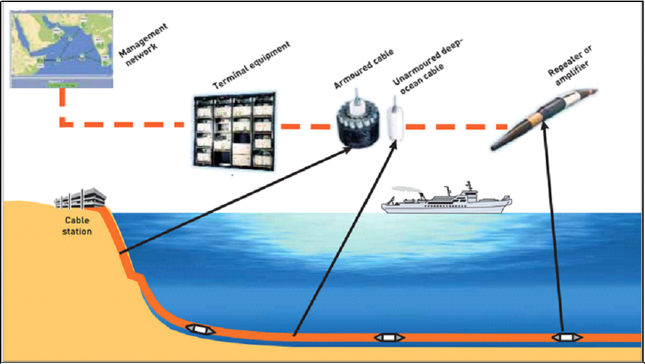

Recreation:

Later that evening, we looked for accommodation at Mtwapa Creek, checked into a Kwetu Resort, and then enjoyed a recreational visit to Kenyatta Beach.

## Day 4: Nyali Marine Data Center, Mombasa

The fourth day began with a visit to the Nyali Marine Data Center tour, where we learned about:

* **Multiplexing and Demultiplexing**: Techniques for combining and separating multiple signals into one transmission medium and then separating them for individual processing.
* **Dense Wavelength Division Multiplexing (DWDM)**- is a critical technology employed in marine landing stations to maximize the data-carrying capacity of submarine optical cables. It enables the transmission of multiple data streams over a single fiber by using different wavelengths of light, significantly increasing the amount of information that can be transmitted
* **Amplifiers and Transponders**:

Amplifiers: Devices that boost signal strength to ensure data can travel long distances.

Transponders: Equipment that receives, amplifies, and retransmits signals at alternate wavelengths.

Submarine Fiber Optic Cable Design

We were also taken through the submarine Fiber optic cable designs which are essential for global telecommunications by transmitting vast amounts of data under the sea. These cables incorporate robust optical fibers encased in layers of protective materials designed to endure harsh marine conditions, such as high pressure, saltwater corrosion, and potential physical impacts. Their construction involves multiple layers: optical fibers for data transmission, protective sheathing for mechanical strength and water resistance, and often a metallic conductor for powering repeaters.

Picture Examples:

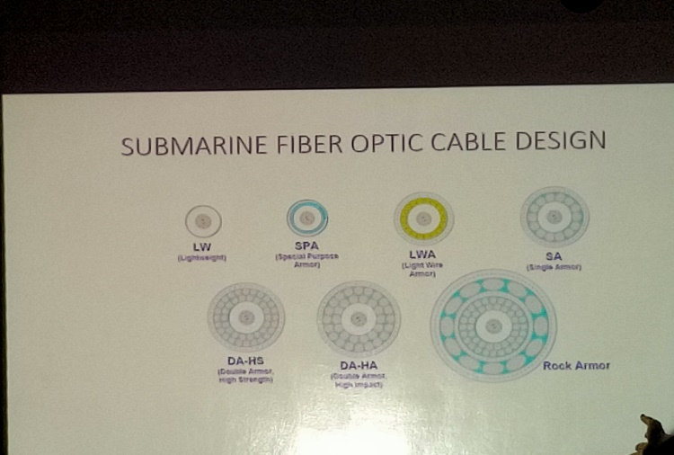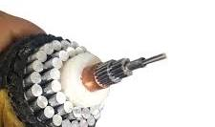

Recreational Activities:

After the technical tour, we returned to Kenyatta Beach for further recreation.

I participated in canoe riding in the deep sea during low tides, took photographs, and observed the coastal mangrove trees

## Day 5: Return Journey – Overnight in Nairobi

*Overview:*

On Day 5, we began our return journey to Karatina University. The travel took longer than expected.

Activities:

Due to the long journey, we arrived in Nairobi around midnight (00:00 hours) and arranged for overnight accommodation in Nairobi before resuming our travel the next day and in the morning we departed from Nairobi and safely returned to Karatina University.

**Conclusion**

The field trip was an enriching experience, providing firsthand exposure to Kenya's ICT infrastructure and its evolution. From the historical artifacts at Multimedia University to the cutting-edge technologies at Konza Technopolis and the Mombasa Cable Landing Station, the trip deepened our understanding of the role of ICT in national development. The knowledge gained will undoubtedly enhance our academic and professional pursuits in the field of technology.

**Acknowledgments**

We extend our gratitude to Karatina University for organizing the trip, the staff at Multimedia University, Konza Technopolis, and the Mombasa Cable Landing Station for their insightful presentations, and our trip coordinators Mr.Zablon Okari and Mr.Vincent Tanui for ensuring a smooth and successful experience.